# **CSSE1001: Sem. 1 2017 exam answers**

[**UQAttic**](http://uqattic.net/)

**Get more out of your study time. Join UQAttic's Semester 1, 2012 revision chat.**

[**Other exam papers**](https://docs.google.com/folder/d/0B_gnBD5zp3rqT2hrLWhvd2Rkc1U/edit)

**Read this page first!**

Please **contribute** to these documents.

If you're looking for an effective way to familiarise yourself with the course material, you can't go past collaborating with fellow students. We have laboured to put these up, and so at the very least point out where you think we are wrong!

You'll get more out of the course, you'll do better in the exam, and other students will benefit from your input as well.

**Style.**

If you're unsure of your answer, highlight your answer text then hit Ctrl+Alt+M to create a comment beside the text. Once you're satisfied with the answer, click the "Resolve" button on the comment.

If you want some extra explanation from someone else on their answer, highlight the other person's answer and repeat the procedure above.

If you are confident that your answer is correct, then just type it in red below each question.

**Communicate.**

Head over to [uqattic.net](http://uqattic.net/) and click "Chat Now!". You'll find a chatroom full of students just like you. Talk about a revision document (like this one) or swap prep tips.

If you have your own IRC client, point it to irc.uqattic.net, port 6667, channel #attic.

You can disable automatic email alerts of comment discussions via the "Discussions" button.

Feel free to contribute, unsure about highlighted answers

1. c
2. d
3. a
4. B WHY?! Strings are sorted alphabetically in python. So ‘a’ is technically less than ‘b’. Ordering of data types is specified in the ASCII table for Python.
5. B isnt this asking for x? But y is x
6. a
7. c
8. d
9. A don’t the get function return [] if the key doesn’t exists? The get method actually returns None by default if the key doesn’t exist.
10. c
11. b no b is correct because that is a print statement. Print statements won’t return anything and if a function does not have a return statement it will return None.Thanks !!
12. D a and d both work why d is the answer?? ( A should be typed like value == A or value == B …) a) doesn’t work because (‘a’ or ‘b’ or ‘c’ or ‘d’) always evaluates to ‘a’. So if you had value = ‘b’ then it would return False.
13. A Why is A answer?? This is how I’ve understood it. So if Python is given a “choice” between True or False booleans, it will default to True. So the statement in the question states (False and False) or (True). Between these two options, Python returns True False&True = False, False or True = True
14. A
15. B , can someone explain this to me ? Why not ‘C’. the user does not access the source codes. They use the programme instead. The answer isn’t C because when you call a method/function/class you’re only concerned with how to implement it, not the algorithm/logic behind the method/function/class. For example, if I wanted to know what split() does, then I’d execute help(str.split) and that would give me its docstring. What I get from that docstring is what it does, and how to use it. I don’t really care about the algorithms of the method that allows me to use the method.
16. d
17. c
18. d
19. C
20. D please explain this is basically a factorial function. As it iterates it multiplies by each number less than x until x hits 1
21. a
22. c
23. d
24. B
25. c please explain. Isn’t name always = None?, so won’t line2 never be ran?
26. b is it possible for a to work as well ? the numbers given were already in float format hence in this case wouldn’t the answer be e as a and b are both acceptable answers. A will get a type error because you cant add a string and an integer or a float. Text in a file will always be given as a string, even if it is written so that it looks like another type. Thanks !
27. c
28. b
29. d
30. c
31. a
32. D
33. D
34. c c should be the answer run in idle to check. Previous answer was B, but c is definitely correct.
35. A

Tutor reason on piazza:

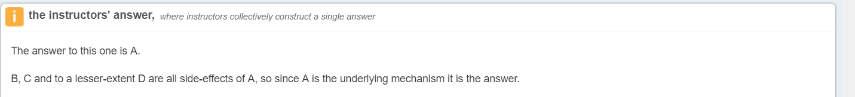

1. A This is correct, see below:
2. E Previous answer was A but this is definitely wrong; the answer should be E as both B and D will work. The expand=1 argument only affects how much space is allocated to a widget, and because the ButtonsFrame has been packed below the ‘Button’ label, it will already have unlimited space allocated to it horizontally. When a frame has widgets packed inside it it will automatically contract as much as possible (stopping button A from having any space around it) unless the fill argument is used.

I tested all of the lines to confirm this:

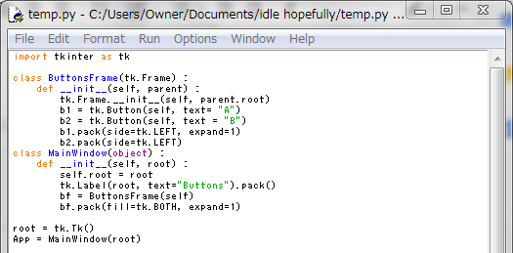

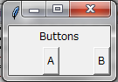

1. D NOT TESTED IN 2018/2 EXAM-+
2. D

c: depending on the implementation you might need to check if they are adjacent or not

e: e is excessive as you probably don’t need to test if there are multiple duplicates or not in a list

1. NOT TESTED IN 2018/2 EXAM